Donor Email Template: Welcome and Campaign Information: Goal, Incentives, Pledge Instructions, Calendar of Events

**Template 2: Welcome and Campaign Information: Goal, Incentives, Pledge Instructions, Calendar of Events**

**From:** Employee Campaign Manager/Committee

**Audience:** All company employees

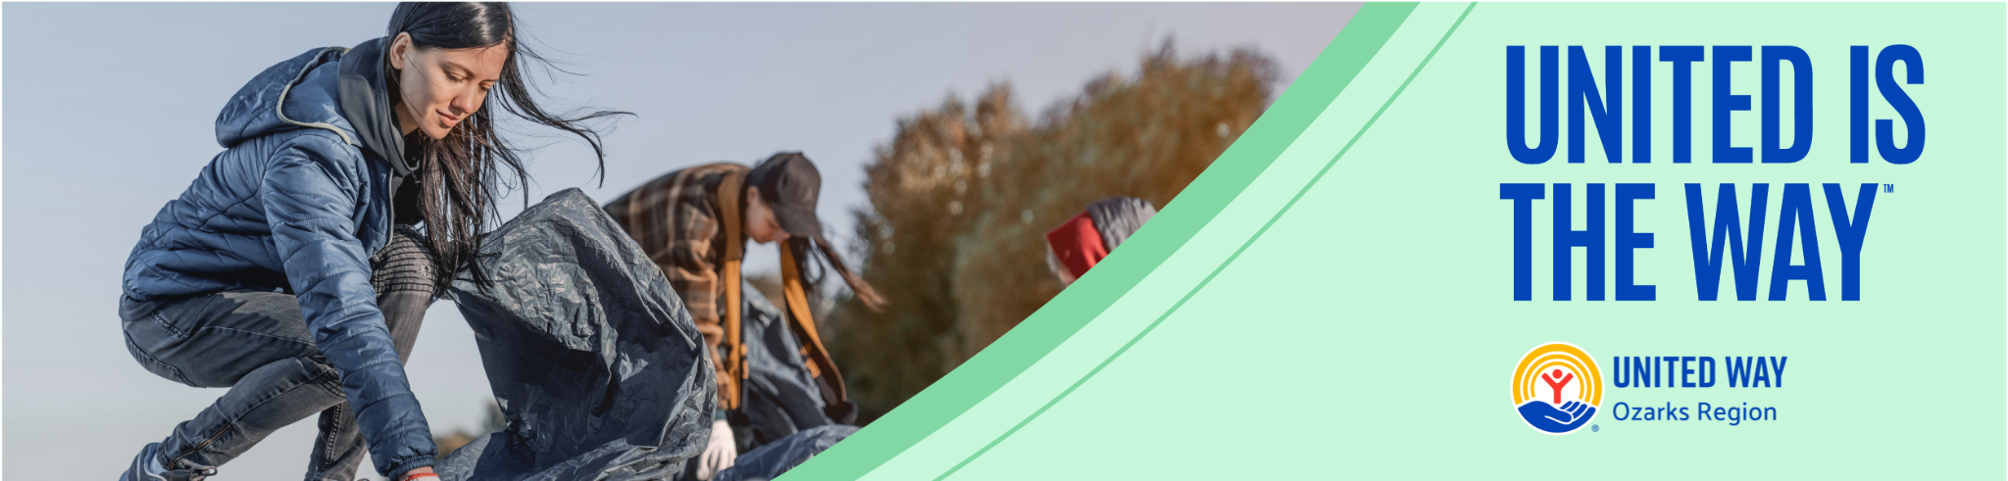   
  
**Subject:** United is the Way: United Way Ozarks Region Campaign

Dear Team,

We are excited to announce that [Your Company Name] is once again participating in the United Way Ozarks Region’s workplace campaign. This year, our goal is [monetary goal or participation goal]. This is a fantastic opportunity for all of us to come together and make a significant impact on our community.

### Why We Participate

At [Your Company Name], we believe in giving back and supporting our community. By partnering with United Way Ozarks Region, we help:

* **Champion Children**: Ensuring every child has access to the education, resources, and support they need to thrive.
* **Provide Pathways Out of Poverty**: Helping individuals and families achieve financial stability and independence.

### How You Can Help

Consider making a donation to the campaign. Every contribution, no matter the size, makes a difference. Here’s how you can make a pledge:

* **Online**: Visit [Pledge Link] to make a secure online donation.
* **Pledge Form**: Complete a pledge form and return it to [employee campaign manager/HR].
* **Rollover**: If you are already giving through payroll deduction, your gift will continue. If you would like to make a change to your pledge, please complete a new pledge form.

### Incentives for Giving

To show our appreciation for your generosity, we have some exciting incentives for those who contribute:

* **[Incentive 1]**: [Description]
* **[Incentive 2]**: [Description]
* **[Incentive 3]**: [Description]

### Upcoming Events

To kick off the campaign and boost our efforts, we have some exciting events planned:

* **[Event Name]**: [Event Date] – [Event Description]
* **[Event Name]**: [Event Date] – [Event Description]
* **[Event Name]**: [Event Date] – [Event Description]

These events are great opportunities to learn more about the campaign, have fun with colleagues, and show our support for United Way.

### Important Dates

* **Campaign Start Date**: [Start Date]
* **Campaign End Date**: [End Date]
* **Pledge Submission Deadline**: [Pledge Deadline]

Let’s unite to create a positive impact and build a stronger, more vibrant community because United is the Way.

Thank you for your generosity and support.

Best regards,

[Your Name]  
[Your Title]  
[Your Company Name]