Donor Email Template: Thank you to donors, announce total raised and campaign stats

**Template 4: Thank you to donors, announce total raised and campaign stats.**

**From:** Employee Campaign Manager/Committee or Leadership/CEO

**Audience:** All company employees

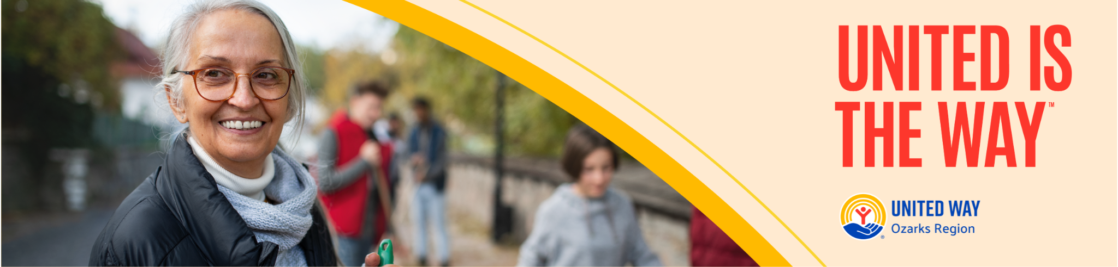

**Subject:** Thank You for proving that United is the Way - United Way Ozarks Region Campaign Results

Dear Team,

As our United Way Ozarks Region’s workplace campaign comes to a close, I want to extend my heartfelt thanks to each and every one of you who participated. Your generosity and commitment to our community have made this campaign a tremendous success.

### Campaign Results

I am thrilled to announce that we have raised a total of [Total Amount Raised] and achieved [X]% participation! This incredible achievement is a testament to the caring and dedicated spirit of our team.

### Making an Impact

By contributing to United Way Ozarks Region, we have collectively helped:

* **Champion Children**: Ensuring that more children have access to the education, resources, and support they need to thrive.
* **Provide Pathways Out of Poverty**: Assisting individuals and families in achieving financial stability and independence.

### Thank You

We couldn’t have reached these heights without your support. Each donation, no matter the size, has contributed to making a meaningful difference in our community. Your generosity embodies the spirit of [Your Company Name] and our commitment to giving back.

### Looking Ahead

While this campaign has ended, our commitment to our community continues. Let's keep the momentum going and continue to support those in need throughout the year.

Thank you once again for your incredible support of the belief that **United is the Way** to a better future for everyone.

Best regards,

[Your Name]  
[Your Title]  
[Your Company Name]