Donor Email Template: Campaign Endorsement from Leadership

**Template 1: Campaign Endorsement from Leadership**

**From:** Leadership Team/CEO

**Audience:** All company employees

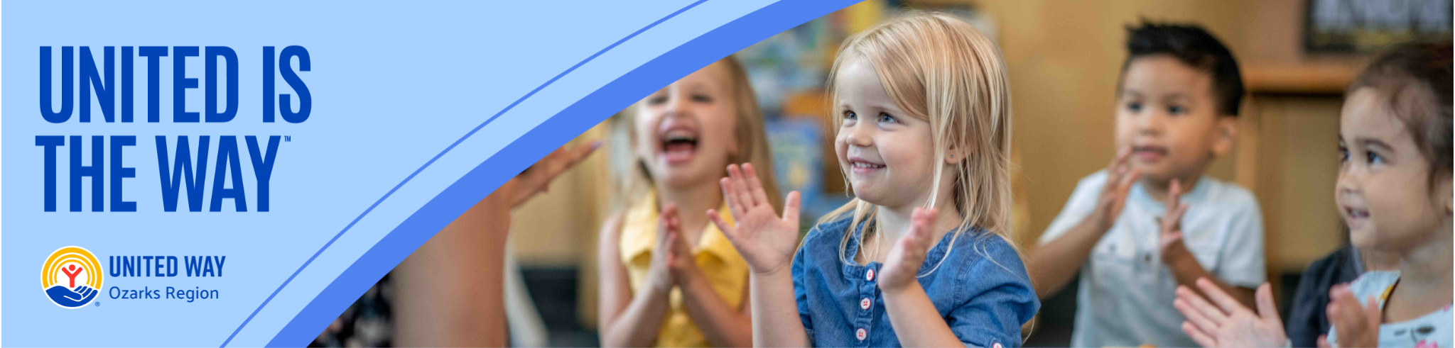

**Subject:** United is the Way: United Way Ozarks Region Campaign

Dear Team,

As we embark on another exciting year of community support, I am thrilled to announce our participation in the United Way Ozarks Region’s workplace campaign. This initiative is not just a campaign but a reflection of our commitment to making a meaningful impact in the lives of those around us.

### Why This Matters

At [Your Company Name], we believe in the power of community and the importance of giving back. Through our partnership with United Way Ozarks Region, we are helping to:

* **Champion Children**: Ensuring every child in our community has the opportunity to succeed.
* **Provide Pathways Out of Poverty**: Supporting individuals and families in achieving financial stability and independence.

### Our Commitment

Our company’s involvement in this campaign highlights our dedication to creating a better, more equitable community. By contributing to United Way, we support vital programs and services that directly benefit those in need.

### How You Can Help

I encourage each of you to consider making a donation to this worthy cause. Your contributions, no matter the amount, make a significant difference. Together, we can transform lives and build a stronger community because we believe United is the Way.

Thank you for your continued generosity and commitment to our community.

Warm regards,

[CEO's Name]  
[CEO's Title]  
[Your Company Name]