Social Tags
Facebook: @uwozarks
Instagram: @uwozarks
X (Twitter): @uwozarks
LinkedIn: @united way ozarks region

Template Social Media Posts
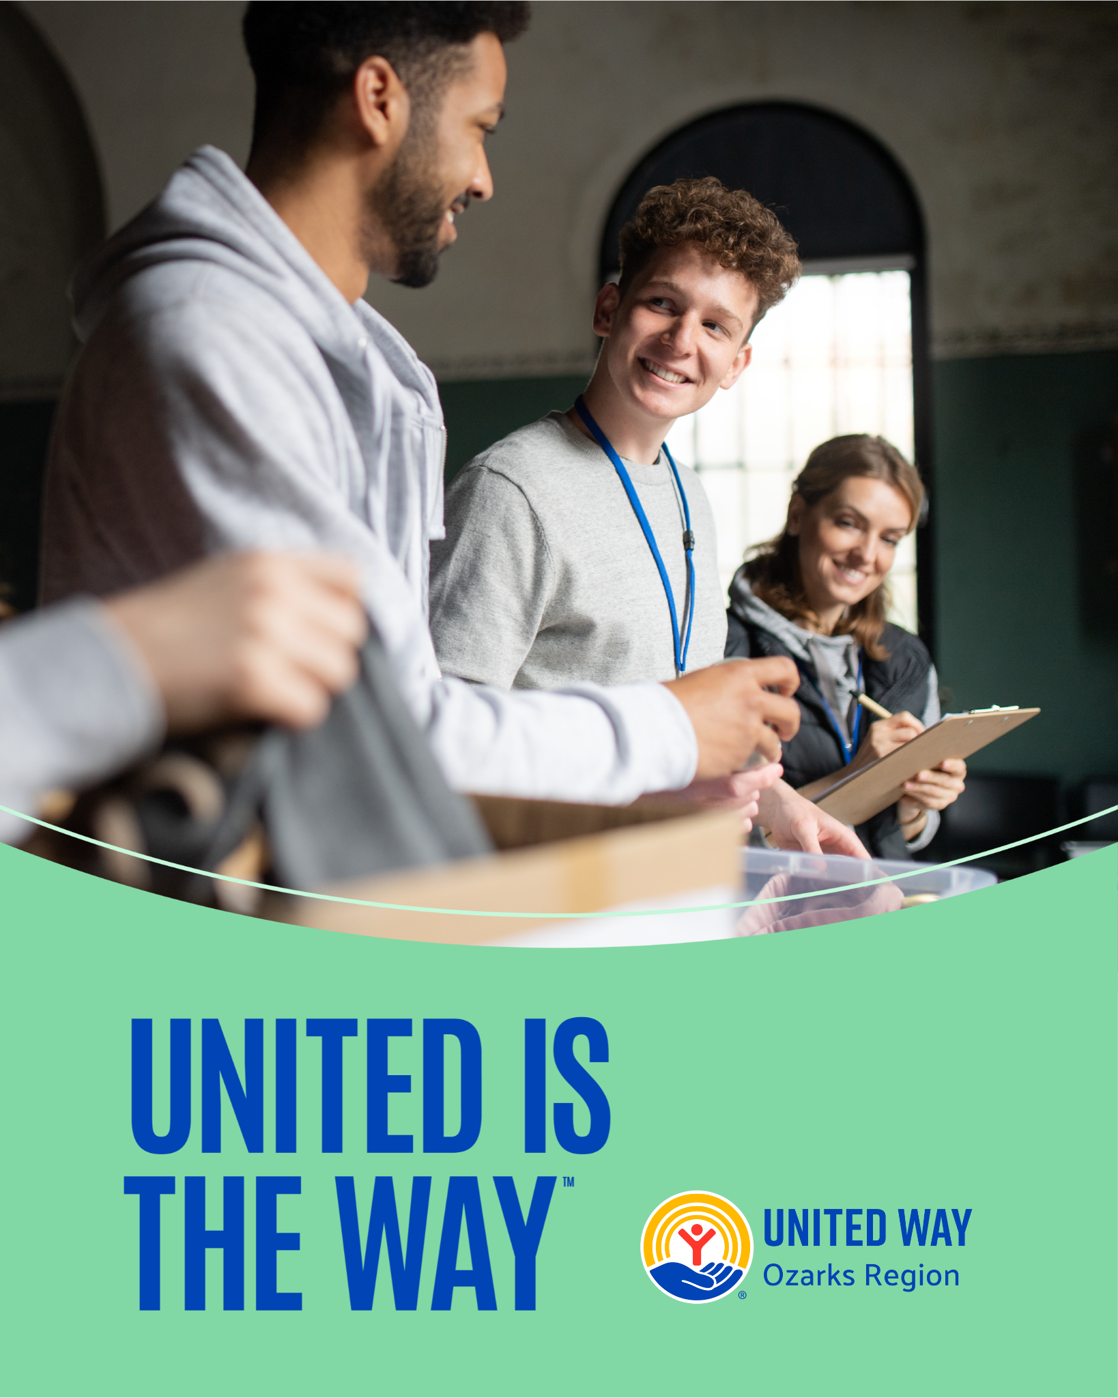
[FB, LI]
🌟 United is the Way. Join us in supporting United Way Ozarks Region! 🌟
At [Your Company Name], we believe in making a difference in our community. That's why we proudly participate in the United Way Ozarks Region’s workplace campaign!

Through our partnership with United Way, we are committed to:
✨ Championing Children: Ensuring every child has access to education, resources, and support to thrive. ✨ Providing Pathways Out of Poverty: Helping individuals and families achieve financial stability and independence.
Our employees' generous contributions help us achieve those goals.

We believe #UnitedistheWay to transform lives and build a stronger, more vibrant community. We encourage other companies and individuals to join us in this vital mission.
Let's make a lasting impact—because when we unite, we create a better tomorrow for everyone.

Join us and be a part of the change! 💙
#UnitedistheWay #UWOzarks #CommunityImpact #ChampioningChildren #PathwaysOutOfPoverty

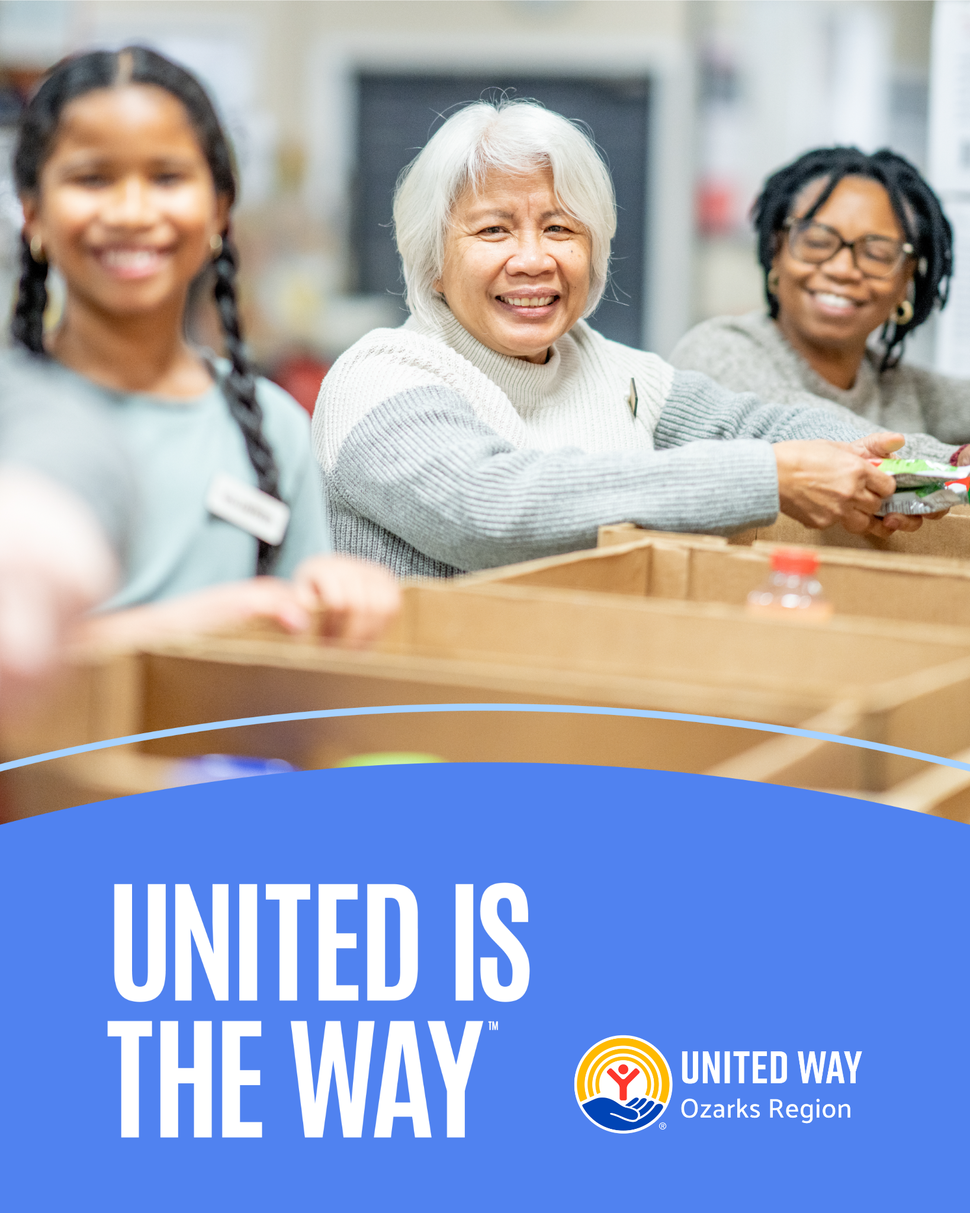
[IG] 🌟 United is the Way with United Way Ozarks Region! 🌟
At [Your Company Name], we’re proud to support United Way Ozarks Region’s workplace campaign. Our team's contributions help champion children and provide pathways out of poverty, making a real difference in our community.
We believe #UnitedistheWay to a brighter future. Join us and make an impact! 💙
#UnitedistheWay #UWOzarks #CommunityImpact #ChampioningChildren #PathwaysOutOfPoverty

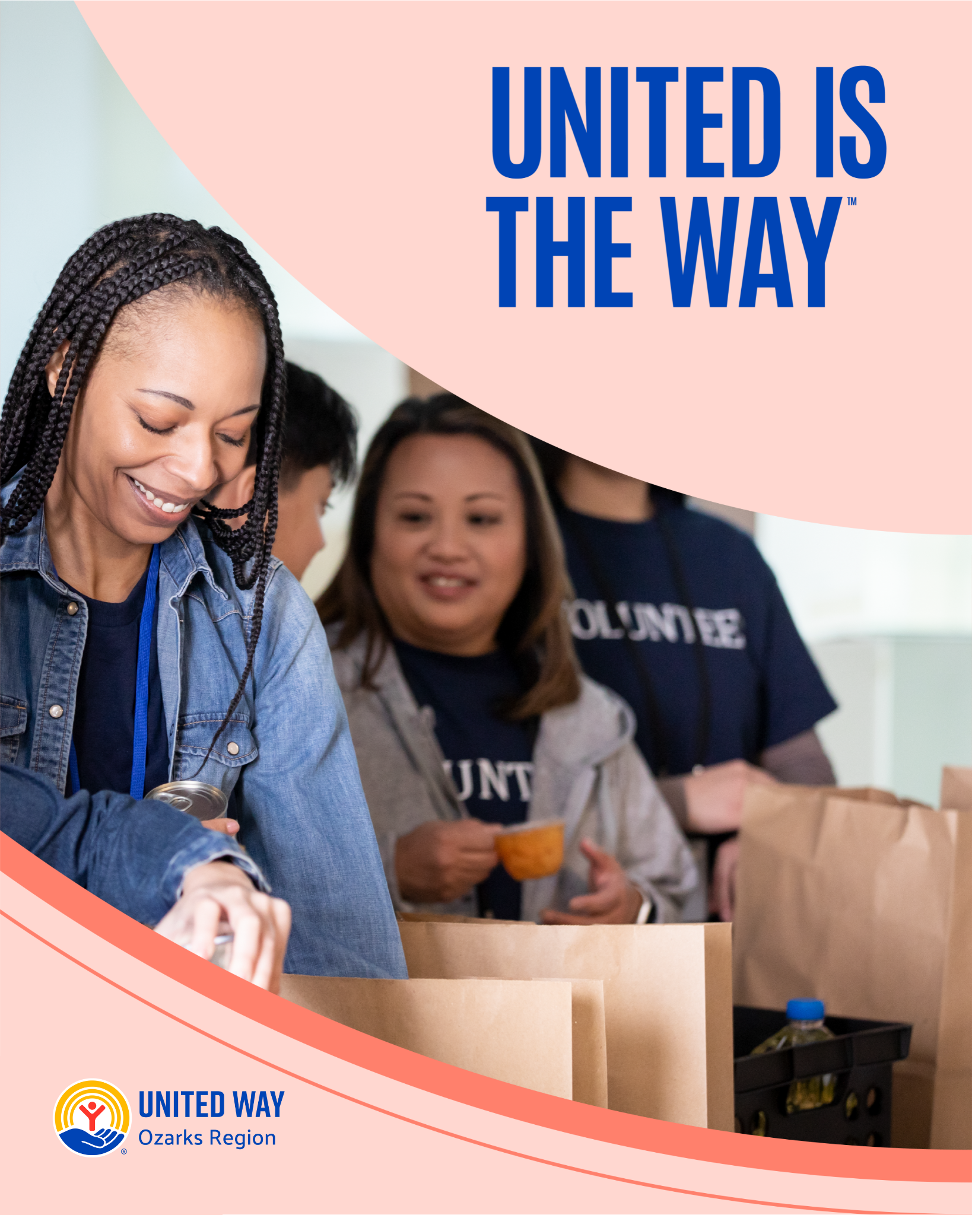
[X] 🌟 At [Your Company Name], we're proud to support @UWOzarks! Our workplace campaign helps champion children & provide pathways out of poverty. We believe #UnitedistheWay to a brighter future. Join us in making an impact! 💙 #UnitedistheWay #ChampioningChildren #PathwaysOutOfPoverty

